HYDRODILATATION
FOR
FROZEN SHOULDER

Patient information sheet

Author: P. Monk and J. Nicholson
Version: SH HHD Document 2019 V1
Date: 2019

Why have I been offered this treatment?

Your Musculoskeletal specialist has diagnosed a Frozen Shoulder (Adhesive Capsulitis) which is a painful condition that causes reduced movement of the shoulder joint.

What is involved?

Hydrodilatation is a procedure that aims to improve the movement and reduce pain of the shoulder. It involves stretching the capsule of the joint (the bag that encloses the ball and socket joint) and reducing inflammation within it by injecting a mixture of sterile saline, local anaesthetic and steroid.

Who will be performing this procedure?

A specially trained doctor, known as a Radiologist or a Musculoskeletal Sonographer performs the procedure using X-ray or Ultrasound guidance to ensure the injection is accurately placed.

The procedure

If your shoulder has not already been scanned, your clinician may conduct a scan of your shoulder first to check there are no significant tendon tears and that it is safe to proceed. This part is usually done in sitting. You will be asked to remove your t-shirt (and place your bra straps under your arm). For the procedure you will lay on your side and the injection usually takes place around the back of the shoulder. This is done using imaging to guide the needle to the right place.

Approx. 35-40ml of fluid (a mixture of Saline/Steroid/Anaesthetic) is injected into the shoulder joint space and the whole process takes up to 25 minutes. It is thought that this mechanically stretches the tight shoulder capsule, although how this procedure actually works has yet to be proven.

Page 2 SH HHD Document 2019 V1 P. Monk and J. Nicholson

What can I expect to feel during and after the procedure?

There may be a sensation of pressure during this procedure; some people describe it as an odd or unusual feeling. Very rarely do people describe it as painful but this can happen and you should tell the clinician if this is the case. Most people are completely comfortable throughout.

Afterwards some people describe it as an odd or unusual feeling like there is excess fluid or heaviness in the shoulder or arm. These symptoms do not always occur and usually resolve quickly. In many cases the movement in the arm is improved immediately.

Is it Safe?

The risks are very small as it is a very safe procedure. Ultrasound is a perfectly safe modality and poses no threat to you during this procedure. Most of the risks are around the use of the steroid part of the injection. A full understanding of these can be found by reading our steroid information leaflet alongside this guide.

You must tell the clinician if you are diabetic; epileptic; on blood thinners; ever had a bad reaction to steroid injections or if you have any allergies to any medicines.

As with any injection, very rarely you may get an infection in the joint. If your joint becomes more painful and hot you should see your doctor immediately, especially if you feel unwell. If this should occur it will need treating in hospital urgently, possibly with a joint washout and a course of intravenous or oral antibiotics. Allergic reaction is an extremely rare but serious side effect of anaesthetic or steroid. This reaction causes swelling and is called an anaphylactic reaction, similar to people who may be allergic to nuts or bee stings or certain materials like latex. If you have any breathing difficulties in the 24 hours following injection you should call an ambulance immediately.

Page 3 SH HHD Document 2019 V1 P. Monk and J. Nicholson
What should I do prior to the procedure?

Please take your normal pain relief medicine one hour prior to your procedure. Bring your reading glasses so you can read the consent form. Please bring along someone to drive you home after the procedure, as we would advise that you do not drive or operate heavy machinery for the rest of that day following the procedure as you may not be insured by your insurance company.

What happens after the procedure?

Some people do have moderate discomfort which can last for thirty minutes to an hour after the procedure. You may get some bruising around the injection site and the numbness of the skin may last for several hours. You will be asked to stay in the department for 15-30 minutes after the procedure before being allowed home. Most people feel back to normal after 24 hours and are usually back to work the next day , although if you have a physical manual job , you may be advised to have a couple of days off.

You should recommence or start Physiotherapy within 7-10 days following the procedure but please start these exercises at the back of this information sheet once you get home from the Hydrodilatation. You should continue with your Physiotherapy exercises for at least 3 months following the procedure to maximize any increased movement gained during the procedure.

Does it work?

There is no cure for frozen shoulder but this treatment speeds up the natural recovery times by aiming to improve the movement and reduce the pain quicker than simply just waiting for it to resolve on its own. Like most medical treatments the evidence is mixed. There is some good evidence to state it is very effective and this fits with our experiences here. Over 70% of patients report improvements in movement and 90% report reductions in pain. Many people notice changes immediately and for some it can take several weeks. It’s important for you to continue with your physiotherapy exercises afterwards.

Page 4 SH HHD Document 2019 V1 P. Monk and J. Nicholson

What if it fails?
It may be appropriate to simply continue with your Physiotherapy exercises until the natural improvement of this condition start to happen or your specialist will discuss the option of a keyhole surgical release (a capsular release) or MUA (manipulation under anaesthetic).

How will I be followed up?
Your Musculoskeletal Specialist who requested the Hydrodilatation, may wish to review you at approximately 6 weeks after the procedure to see how you are progressing.

Your questions or concerns?
Your Musculoskeletal Specialist who has referred you will be able to answer any queries you may have. You can also contact us sing the contact form on our website:
https://advancedphysiosolutions.co.uk/contact-us/

We would like to acknowledge the West Suffolk NHS Foundation Trust information sheet on Shoulder Hydrodilation and Wrightington, Wigan and Leigh NHS Foundation Trust Hydrodilatation sheet.

Page 5 SH HHD Document 2019 V1 P. Monk and J. Nicholson
Home exercises to start when you get home 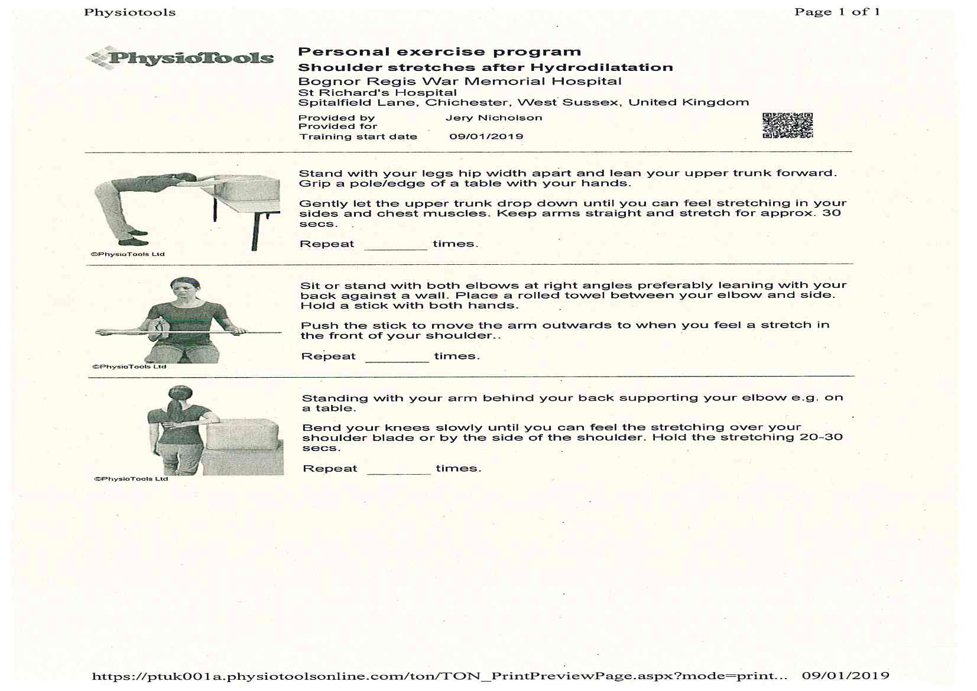

Page 6 SH HHD Document 2019 V1 P. Monk and J. Nicholson

